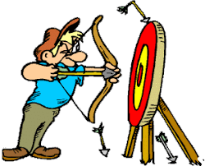

***SCBA***

***Traditional Bow Classic***

**Saturday May 18, 2024**

***Open to All***

***It’s Back***… The SCBA Traditional Bow Classic Competition

25 - 3D targets in the cool pinons at the SCBA range.

***Grab your sticks and come on out and compete!***

Competition Classes:

1. Open Class - Traditional (Sights, Stabilizers, Weights, etc.)
2. Adult Male – Bare Bow Traditional
3. Adult Female - Bare Bow Traditional

Prizes for each class 1 to 3

***1st Place – 2nd Place – 3rd Place –***

1. Young Adult 12 to 17 – (one class all bows)
2. Youth 5 to 11- (one class all bows)

Prizes for each class 4 and 5

***1st Place – only***

**Registration**: 8am-9am – Shoot starts at 9:15am

**Entree fees:**

Ages 18+: $20 Members ($30 Non-Members)

Ages 15-17: $10 Members ($15 Non-Members)

Ages 14 and under are FREE

For more information, visit

http://www.scbaarchery.org.

SCBA operates in cooperation with Bernalillo County Parks and

NO smoking NO drugs or alcohol NO firearms