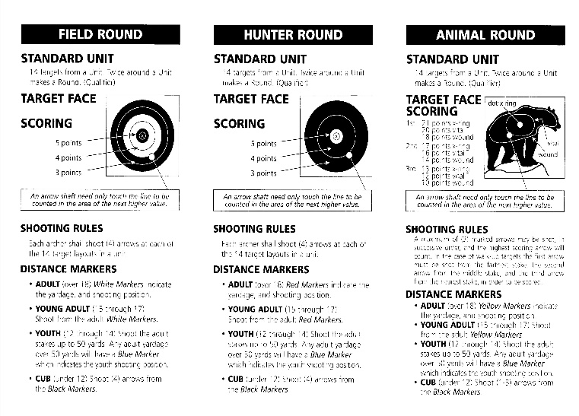

**Saturday October 14, 2021**

**Open to All / Includes a Pizza Lunch**

The SCBA will be hosting a NFAA style shoot on Saturday, October 14. The *Half-n-Half* will feature a ½ competition Field Round followed by a ½ competition Animal Round. Scoring will be based on NFAA competition rules and the official NFAA targets. The combined score will determine division winners.

If you haven’t shot an NFAA outdoor competition before, there are lots of fun. This competition will be open to everyone, and the fee includes lunch, you don’t have to be a member of the NFAA or the SCBA to compete. Just come on out and enjoy the day!!!!!

* **Prizes**- $15 of proceeds from registration by division will be paid back to that division for 1st place. If a division has more than 4 participants, then 70% of winnings will be paid to 1st place and 30% to 2nd place, 6 or more 1st place 50%, 2nd place 30%, 3rd place 20%. Participants can move to more competitive or a larger division if it is age / category appropriate and decided before the competition starts. For competitors 10 and under, no cash prizes with a minimal fee.

**Registration** 8:30am- 9:15am

competition begins at 9:30am

**Entry fee:**

**$25 per person**

**10yrs and under $5- includes lunch**

**(10 and under no cash prizes)**

**‘The Charlie Barnes’**

*Half-n-Half*

**2nd Annual NFAA Competition**

NO smoking NO drugs or alcohol NO firearms

For more information visit:

http://www.scbaarchery.org.

SCBA operates in cooperation with Bernalillo County Parks and Recreation.